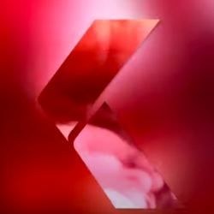

**Uncle: A public Ride Request Service**

**Market Research at:**

**Sci-Bono Discovery Center**

**Budget: R1000**

**To Whom, It May Concern**

**Greetings: Hope this email receives you well.**

Uncle, is interested in Conducting a Mini-Market Research at, Sci-bono Discovery Center.

Due, to the Traffic that Sci-Bono gets: from schools: The kings discovery school, Forest town, Coronation school, North vague secondary school, Roadsfield, St davids, Weaverly girls, Mthashana college), Visitors, Traffic Departments, event caterers (school of culinary art courtesy), Sasol science.

**What is Uncle:**

Uncle, is a Digital platform for Hauling cabs.

Our objectives are as follows:

Proposed Market Research Timeline:

* Timeline 1:

10 August 2023 to 10 October 2023:

1. We would Appreciated it, if we could exhibit the Protype Stand for 2 Months(From , 10 August 2023 to 10 October 2023) at Sci-Bono, For Market Research (To see how people react to it) and to show case to potential Investors.

* Timeline 2:

01 November 2023-15 November 2023

1. We, would like to Have one of our Protype stands: to be exhibited on the **IT Academy November Graduation Ceremony 2023** in order to implement the findings from (10 August 2023 to 10 Octocter) Market Research.

**\*Additional:**

**Material Help:**

**Material: Skin Fabric (1.9Metres X 0.78Metres X 4.5 Meters)**

* Help in Skin covering Material (): we opted for a black all over skin. We are asking to help furnish the Stand below:

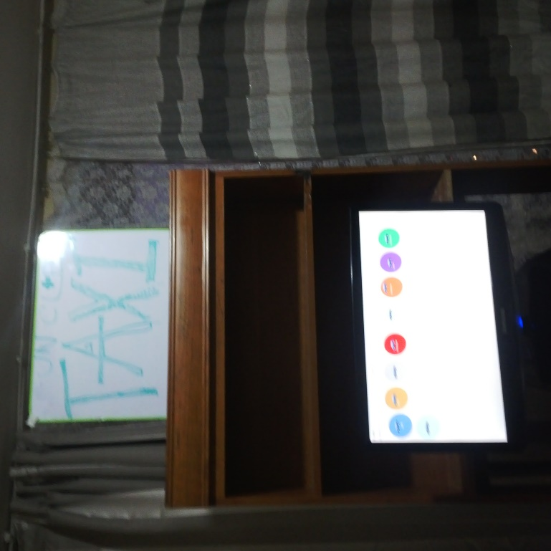

45Meters

0.78Meters

1.9Meters

Uncle & Console.log Data would like to appeal to the (HOD,) of Exhibitory, Mr. Edward to assist and approve, of the above objectives.

Thank you in advance for your Consideration.

website: https://yaetchts.github.io/uncle/

Yours Sincerely

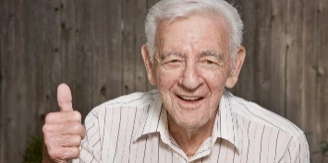

Uncle.